Lab 8: Adult Survival: MARK known-fate analysis

Population Viability Analysis: Vortex

NRES 470/670

April 28, 2017

Program MARK: Known-Fate Model

When we know the fate of each individual with certainty we can use the known-fate model. In these models encounter probability is 1.0. Studies utilizing radio-marked individuals are good candidates for known-fate. Collar data can be imported in an input file and then be used to estimate survival probability (S) based on a variety of factors (covariates). Known-fate models estimate survival probability between sampling occasions. We know the status of the individual (alive or dead) and therefore precision is usually quite high.

Below is a portion of the capture history used in the input file for this lab. The columns represent monthly occasion intervals. Each row is a capture history for an individual.



An abbreviated version might look something like:

|  |  |  |  |  |  |  |
| --- | --- | --- | --- | --- | --- | --- |
| **Occasion 1** | **Occasion 2** | **Occasion 3** | **Occasion 4** | **Occasion 5** | **Occasion 6** | **Occasion 7** |
| **00** | **10** | **10** | **10** | **11** | **0** | **0** |

“00” indicates that individual is absent in that study at that occasion

“10” indicates the individual being present and alive for that occasion

“11” indicates the individual is dead at that occasion

So the above example would read: Individual absent from the study for the first occasion. Present and alive for the next three occasions. Dead at the fourth occasion and absent for the remaining two occasions.

**Exercise 2- Known-Fate models in Program MARK**

Question 2a:

Write out a known-fate history for an animal that was tagged and present in the first occasion of a 5 year study and then died in the third year.

Open Program Mark and load the provided know-fate model titled: PDH_KnownFate.

Three different models should already be loaded. These models allow time to vary differently.

The display should look like:

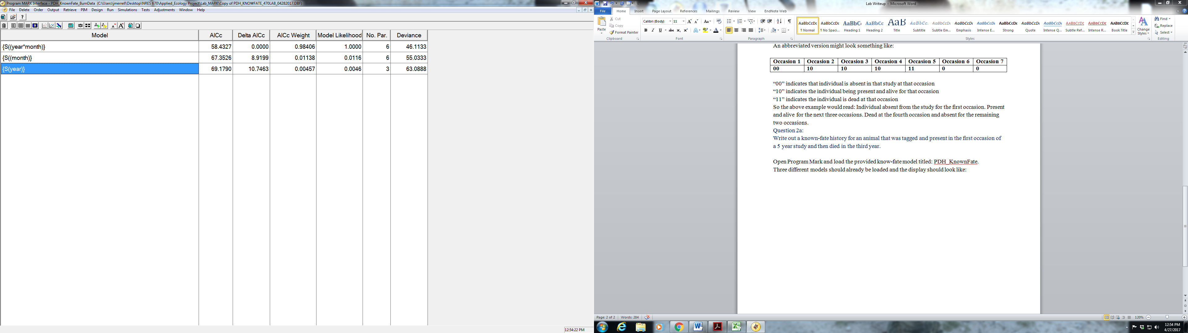

Model 1: S(year) is allowing time to vary by year.

Right click on this model. Select “Retrieve”. This will bring up the design matrix for this model.

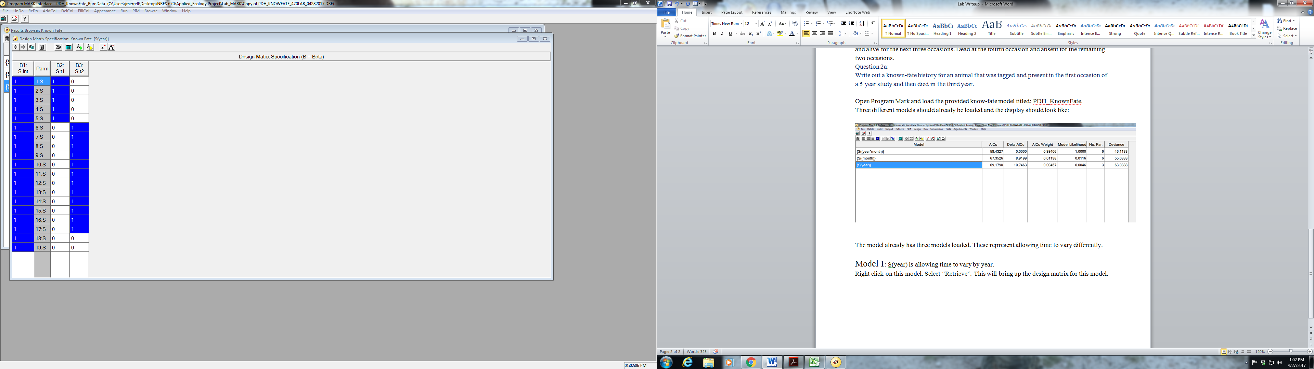

Model 2: S(month) is comparing months against each other. (i.e., all Mays together, all June’s together…) Right click and retrieve this model.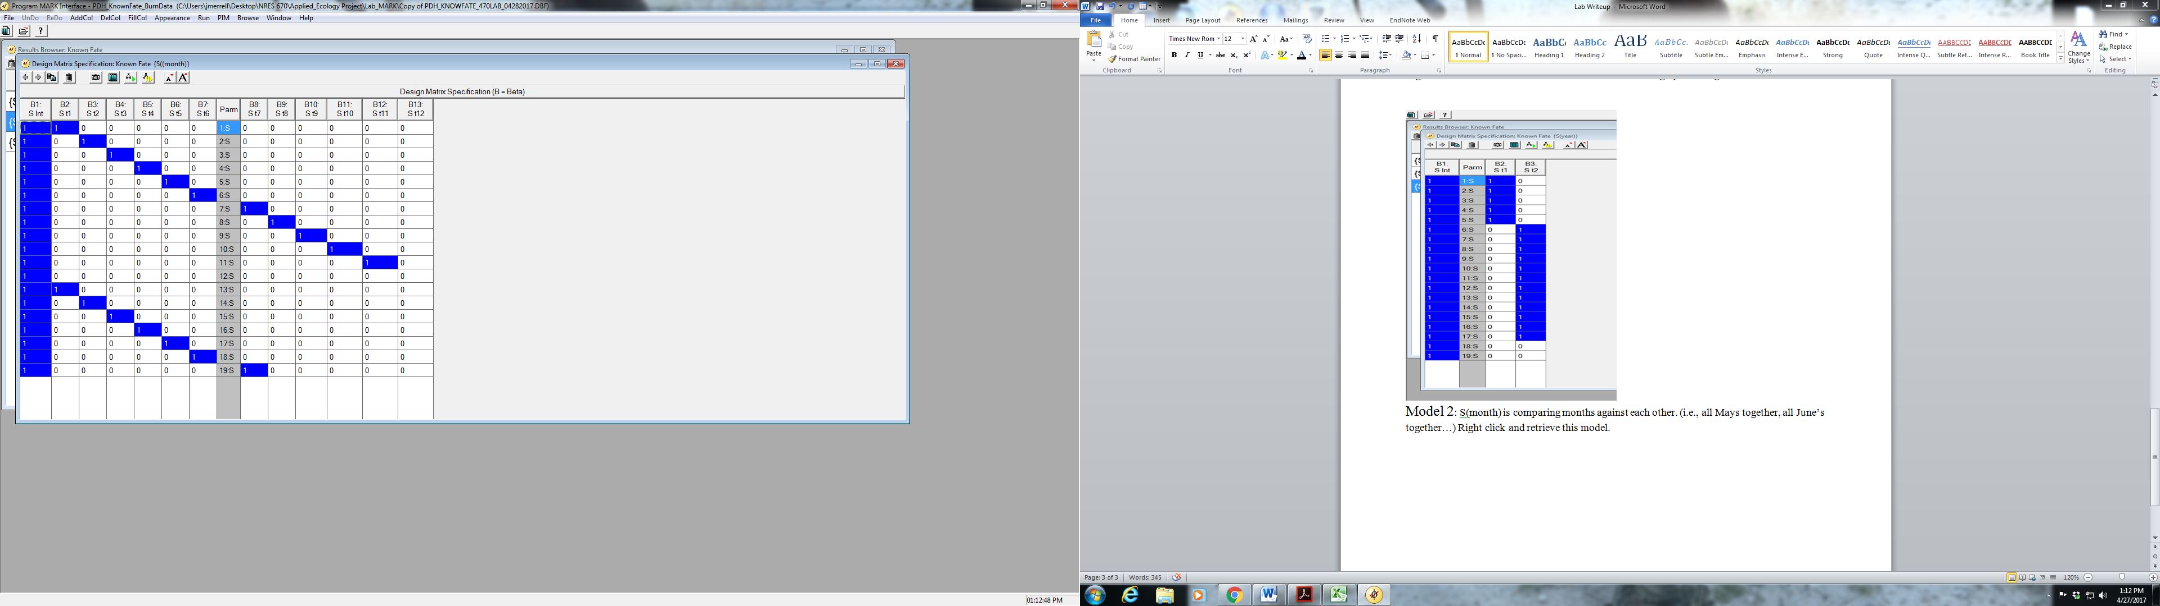

Model 3: S(year*month) is allowing each month to vary independently and is the top model for time. Right click and retrieve.

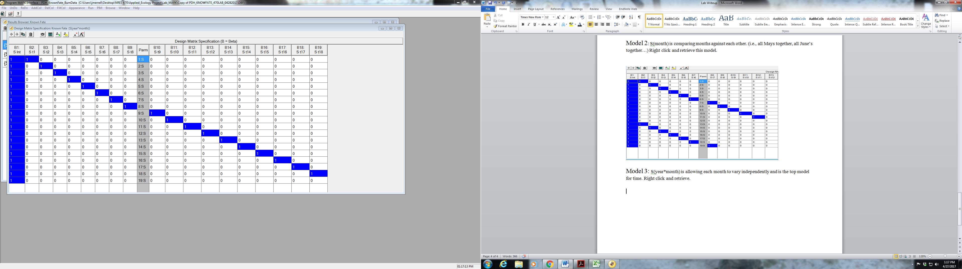

**Adding Covariates!!**

Covariate table

|  |  |
| --- | --- |
| **Body Condition Scores** |  |
| Body Length | Overall Body Length |
| Weight | Visually estimated body weight |
| Ribs | Body Condition Score-Ribs |
| Pelvis | Body Condition Score-Pelvis |
| Total | Total of all Body Condition Scores |
| **Migration** |  |
| 15_AM_STRT | 2015 Autumn Migration -Start Day |
| 15_AM_DAYS | 2015 Autumn Migration-Total Days Spent Migrating |
| 15_AM_DIST | 2015 Autumn Migration-Total Distance Migrated |
| 15_AM_SO_D | 2015 Autumn Migration-Number of Days Spent at Stop Over Sites |
| 16_SM_STRT | 2015 Spring Migration -Start Day |
| 16_SM_DAYS | 2015 Spring Migration-Total Days Spent Migrating |
| 16_SM_DIST | 2015 Spring Migration-Total Distance Migrated |
| 16_SM_SO_D | 2016 Spring Migration-Number of Days Spent at Stop Over Sites |
| 16_AM_STRT | 2016 Autumn Migration -Start Day |
| 16_AM_DAYS | 2016 Autumn Migration-Total Days Spent Migrating |
| 16_AM_DIST | 2016 Autumn Migration-Total Distance Migrated |
| 16_AM_SO_D | 2016 Autumn Migration-Number of Days Spent at Stop Over Sites |
| **King Fire Burn Usage** |  |
| 15_AM_MDIB | 2015 Autumn Migration Days Spent in Burn |
| 15_Total_D | Total Days Spent in Burn Area for 2015 |
| 16_SM_MDIB | 2016 Spring Migration Days Spent in Burn |
| 16_AM_MDIB | Total Days Spent in Burn Area for 2016 |
| 16­_Total_D | Total Days Spent in Burn Area for 2016 |

Now that we have our top model for time we can start adding covariates to see if we can strengthen the model. Select the S(year*month) model and retrieve the design matrix. Right click and a list will appear. Select “Add One Column”. Right click over the new Column and select “Individual Covariates” and a list of all the covariates will appear. Select the “Species” covariate (the Pacific Deer Herd has both mule and black tail deer) and add to the model. Run the model with the name {S(year*month+species)}(leave all other settings the same).

2b. Did adding species to this model improve it?

2c. Take your current top model and separately add “GIRTH”, “WEIGHT” and “PELVIS”. Which of the body condition covariates was best at predicting survival?

2d. Now we will add environmental factors to our model to see what effects they might have. Determining if days spent in the King Fire burn are influencing survival. Construct a model (using your current top model as a starting point) that incorporates days spent in the burn area throughout the year. Keep in mind that the occurrences are not all happening in the same year and that there are covariates vary by year. There is a table below that will help match up occurrences to months.

Did spending time within the burn area have an effect on survival? What would be the biological reasoning driving this?

|  |  |  |  |
| --- | --- | --- | --- |
| 1:S | August-15 | 11:S | June-16 |
| 2:S | September-15 | 12:S | July-16 |
| 3:S | October-15 | 13:S | August-16 |
| 4:S | November-15 | 14:S | September-16 |
| 5:S | December-15 | 15:S | October-16 |
| 6:S | January-16 | 16:S | November-16 |
| 7:S | February-16 | 17:S | December-16 |
| 8:S | March-16 | 18:S | January-17 |
| 9:S | April-16 | 19:S | February-17 |
| 10:S | May-16 |  |  |